**Testing Code Coverage**

This section will guide you to:

* Create and commit a Jenkinsfile which uses JaCoCo
* Configure a pipeline to run from a Jenkinsfile and publish coverage results

**Step 1:** Creating a Git repository for the Review Analyzer program

* Login to your Github account.
* Click on the plus icon next to the profile picture and select *New repository* from the drop-down menu.

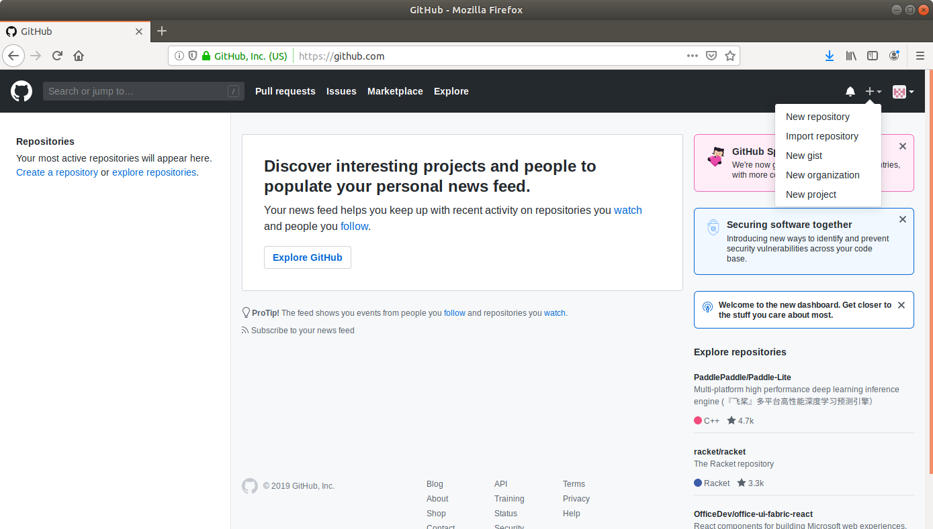

* Fill the required fields in the Create Repository form.

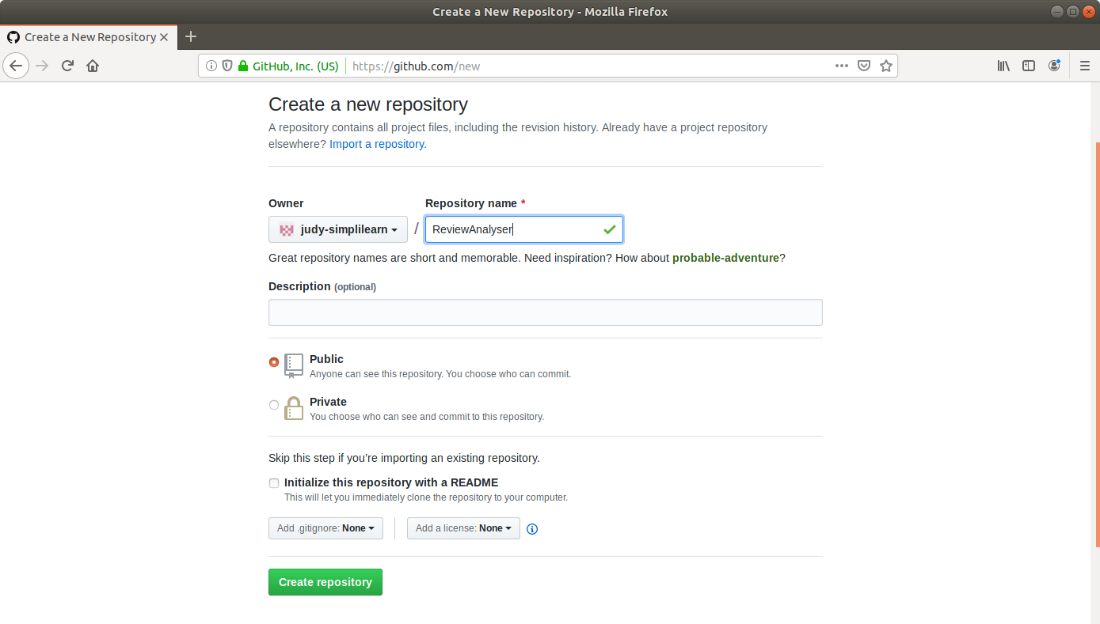

* Click on the **Create Repository** button.
* Click on the **Clone or download** button and copy the URL.

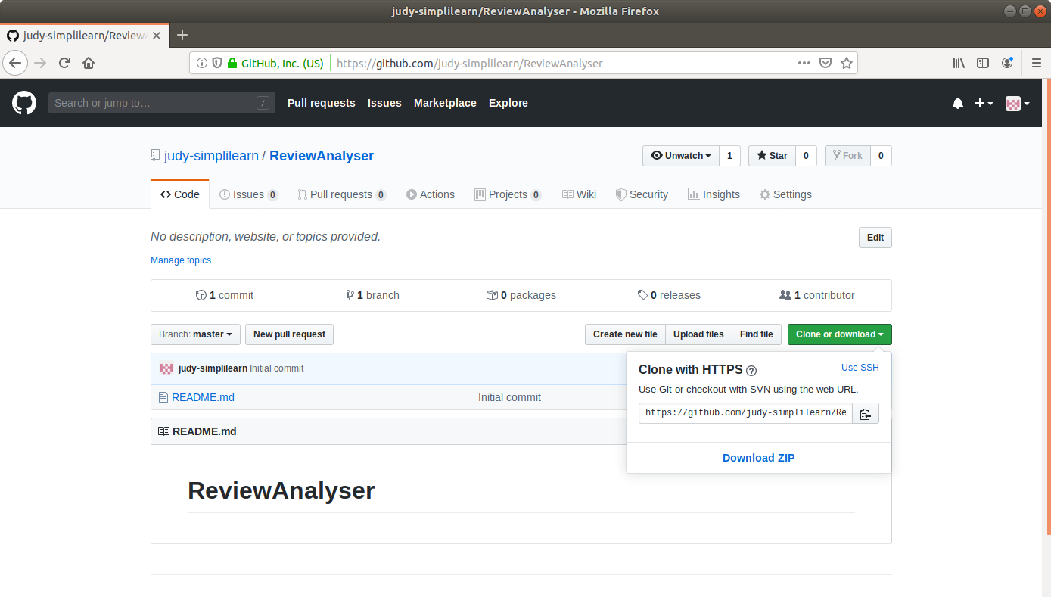

**Step 2:** Generating a spring boot project

* Go to ​start.​spring.​io/​

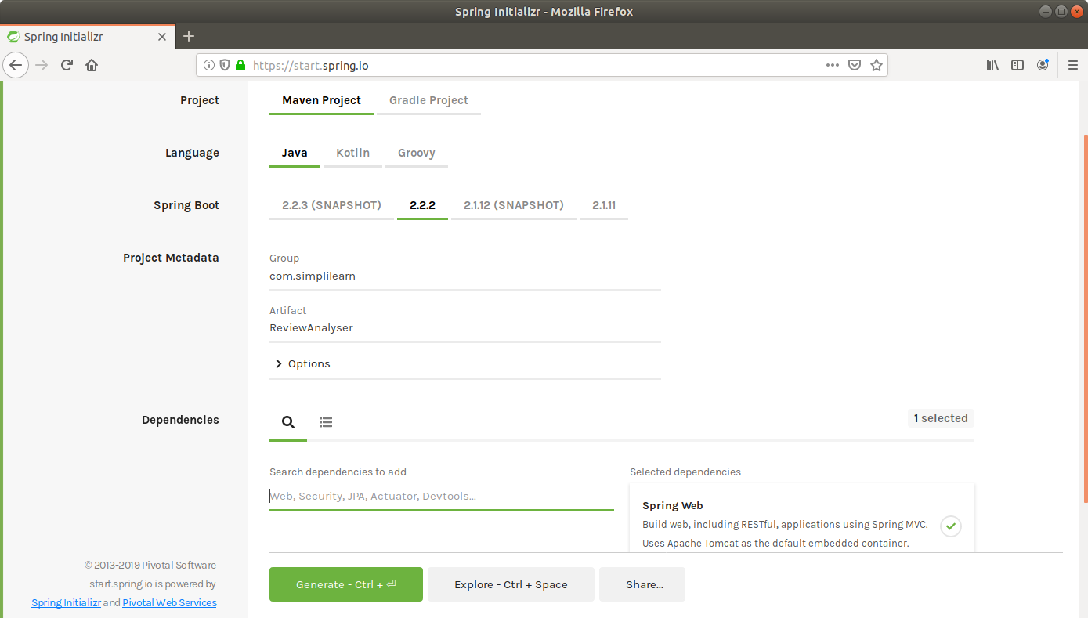

* Select Maven as the project type.
* Fill Group and Artifact with appropriate values. For example, *com.simplilearn* and *ReviewAnalyser.*
* Add **Web** to Dependencies.
* Click on **Generate Project.**
* The generated skeleton project should be downloaded as a zip file.

**Step 3:** Adding the code for word count to the repository

* Open the terminal and navigate to an appropriate location.
* Run **git clone [URL]** to clone the repository.
* Unzip the downloaded spring boot project to the cloned repository.

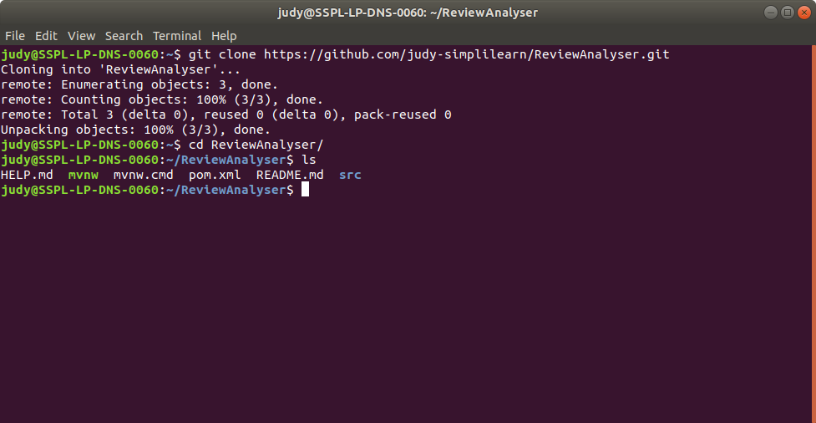

* Navigate to the *ReviewAnalyser* folder within the *src* folder.
* Open the **ReviewAnalyserApplication.java** in a text editor.
* Add the following method to the file and save it.

**package com.simplilearn.ReviewAnalyser;**

**import org.springframework.boot.SpringApplication;**

**import org.springframework.boot.autoconfigure.SpringBootApplication;**

**@SpringBootApplication**

**public class ReviewAnalyserApplication {**

**public static double getWordCount(String review){**

**int count = 0;**

**String string[] = review.toLowerCase().split("([,.\\s]+)");**

**for(String s : string){**

**count++;**

**}**

**return count;**

**}**

**public static void main(String[] args) {**

**SpringApplication.run(ReviewAnalyserApplication.class, args);**

**}**

**}**

* Navigate to the *ReviewAnalyser* folder within the *test* folder.
* Open the **ReviewAnalyserApplicationTests.java** in a text editor.
* Add the following *test* method to the file and save it.

**package com.simplilearn.ReviewAnalyser;**

**import org.junit.Test;**

**import static org.junit.Assert.*;**

**import org.springframework.boot.test.context.SpringBootTest;**

**@SpringBootTest**

**class ReviewAnalyserApplicationTests {**

**private ReviewAnalyserApplication analyser = new ReviewAnalyserApplication();**

**@Test**

**public void testWordCount() {**

**assertEquals(7,analyser.getWordCount("Train to win in the digital economy"));**

**}**

**}**

* Save the file and exit the text editor.
* Open the pom.xml and add the following dependency.

**<dependency>**

**<groupId>junit</groupId>**

**<artifactId>junit-dep</artifactId>**

**<version>4.8.2</version>**

**<scope>test</scope>**

**</dependency>**

* Add the jacoco plugin to pom.xml with the following xml code:

**<plugin>**

**<groupId>org.jacoco</groupId>**

**<artifactId>jacoco-maven-plugin</artifactId>**

**<version>0.8.3</version>**

**<executions>**

**<execution>**

**<id>default-prepare-agent</id>**

**<goals>**

**<goal>prepare-agent</goal>**

**</goals>**

**</execution>**

**<execution>**

**<id>default-report</id>**

**<phase>prepare-package</phase>**

**<goals>**

**<goal>report</goal>**

**</goals>**

**</execution>**

**</executions>**

**</plugin>**

* Save the file and exit the text editor.

**Step 4:** Creating and committing a Jenkinsfile

* Navigate to the *ReviewAnalyser* root directory where the pom.xml is.
* Open a new text file and add the following script to it.

**pipeline {**

**agent any**

**stages {**

**stage("Compile") {**

**steps {**

**sh "mvn compile"**

**}**

**}**

**stage("Unit test") {**

**steps {**

**sh "mvn test"**

**}**

**}**

**}**

**post {**

**always {**

**step([$class: 'JacocoPublisher',**

**execPattern: 'target/*.exec',**

**classPattern: 'target/classes',**

**sourcePattern: 'src/main/java',**

**exclusionPattern: 'src/test*'**

**])**

**}**

**}**

**}**

* Save the file as **Jenkinsfile** with no extension.
* Commit the changes to the remote SCM.
* Run **git add .**
* Run **git commit -m “Add logic and test”**
* Run **git push -u origin master**

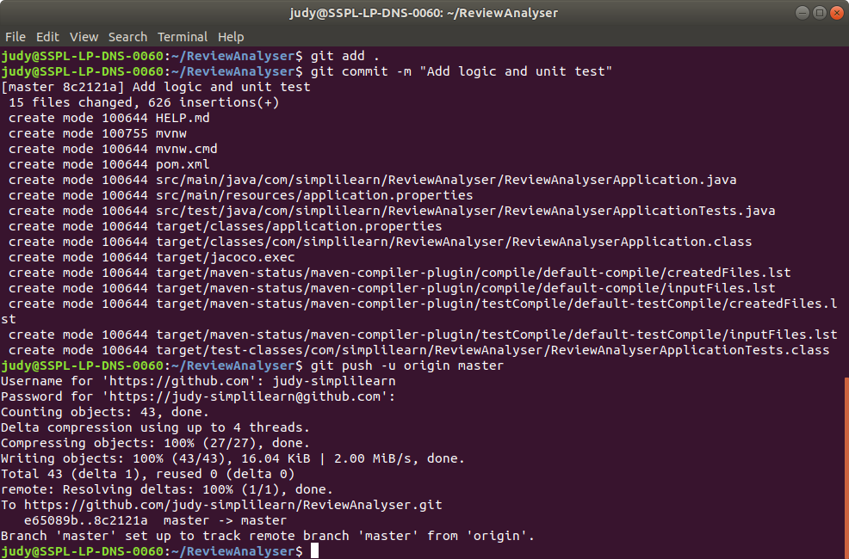

**Step 5:** Creating a multistage pipeline in Jenkins

* Go to Jenkins dashboard.
* Click on *New Item*.
* Enter a name for your build job.
* Select *Pipeline* as the build job type.

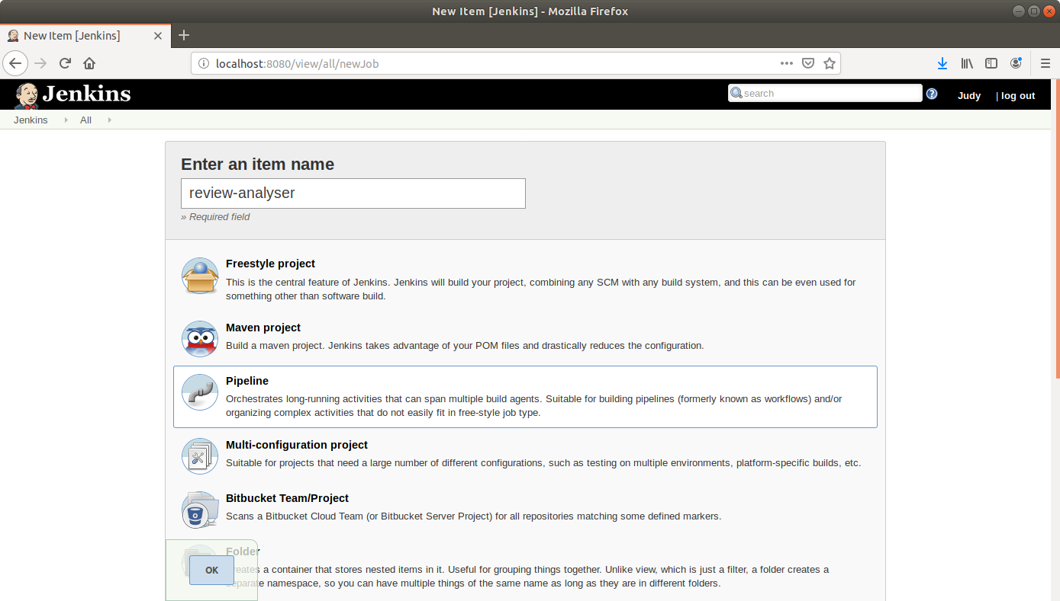

* Click OK.
* On the configuration page, scroll down to the Pipeline section.
* Change *Definition* from *Pipeline script* to *Pipeline script from SCM.*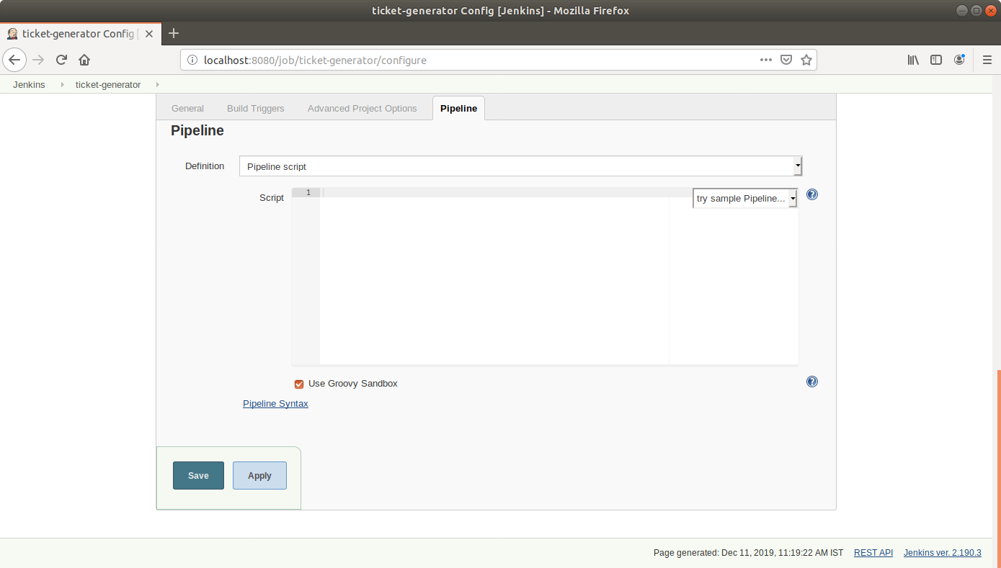
* Select *Git in SCM.*
* Add the repository URL.

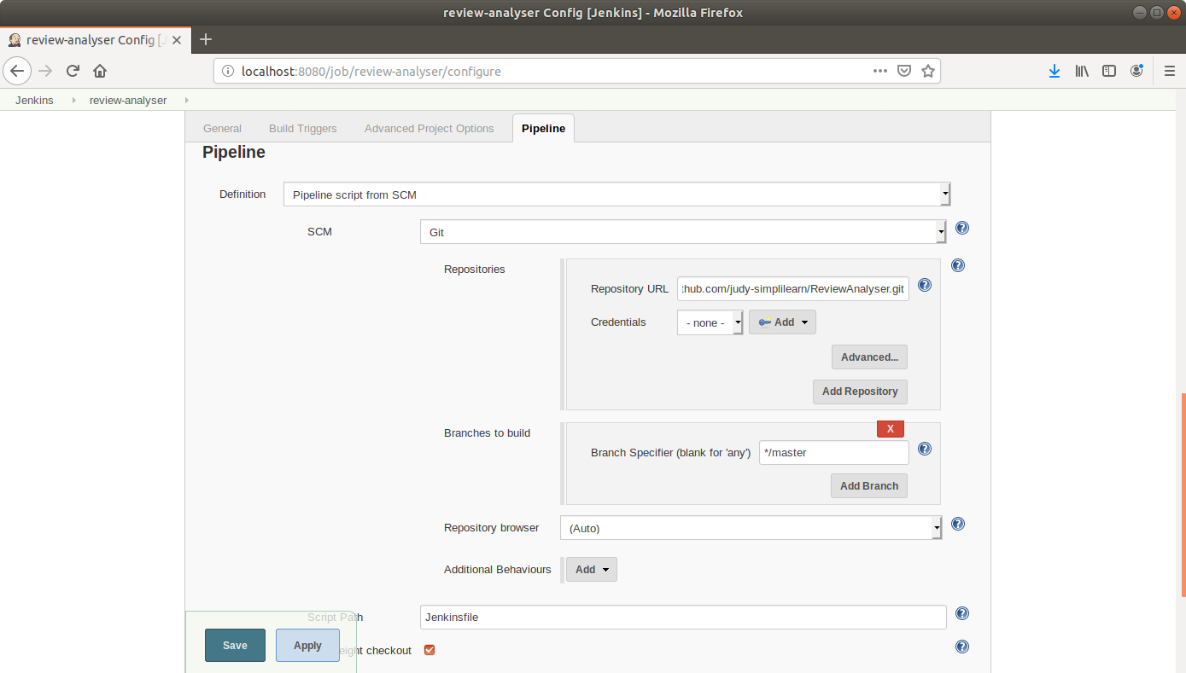

* Click Save.

**Step 6:** Running a multistage pipeline in Jenkins

* Click on *Build Now* in the project window.
* Jenkins will now build your pipeline and output the logs.

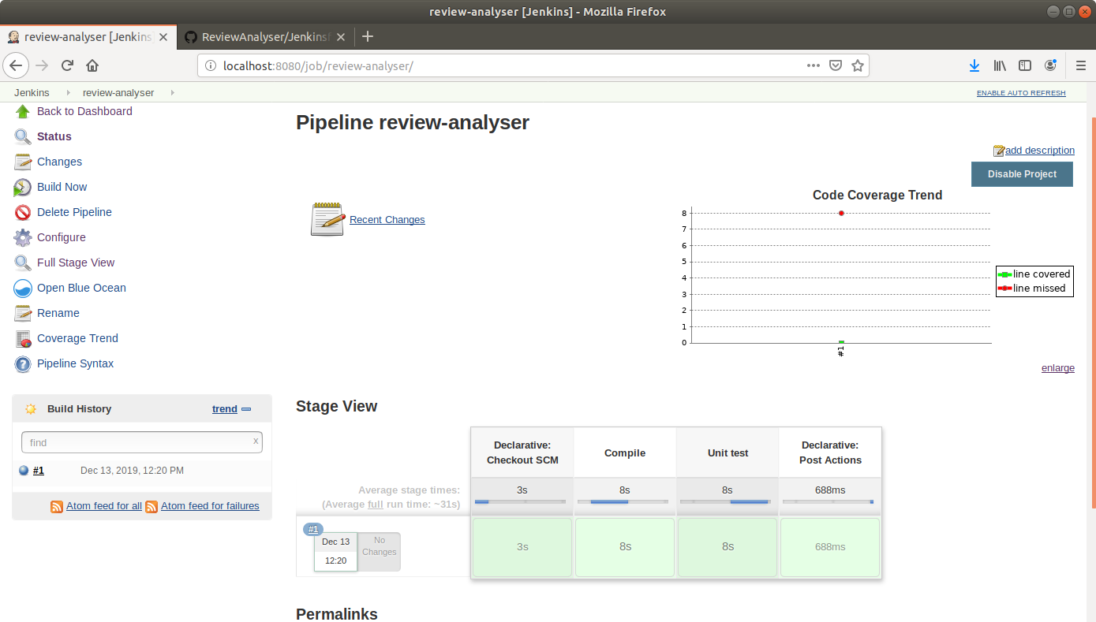

* Click on *Coverage Trend* to view the coverage trend.

